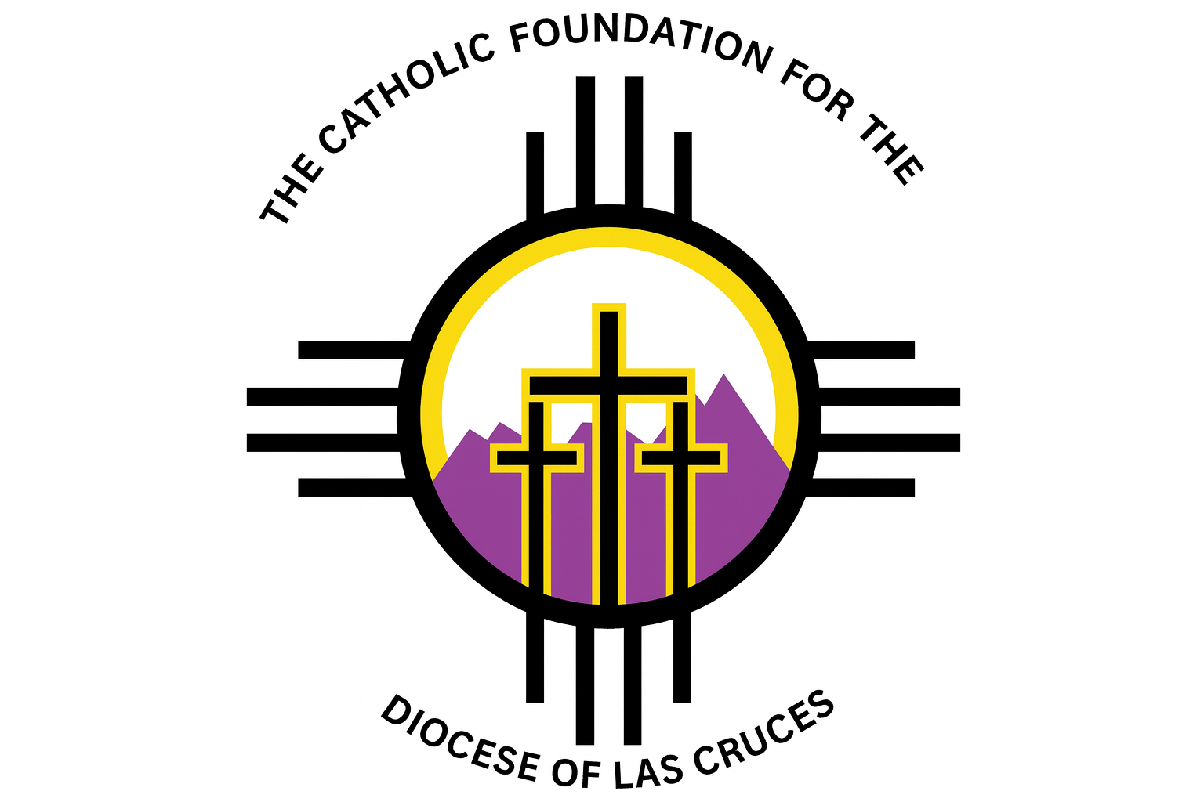
The Catholic Foundation for the Diocese of Las Cruces
Religious & Charitable Ministries Grant Program
Grant Application 2025

- Deadline: October 31, 2025. ATTACH ADDITIONAL SHEETS AS NECESSARY
Submit to:
Rosie Duran, Executive Director, 303 Three Cross Dr., Roswell, NM 88201
rduran@cfdolc.org

Section 1: Applicant Information
- Parish/Mission/Ministry Name: ___________________________
- Mailing Address: ________________________________________
- Contact Person: ____________________ Phone: ___________ Email: ____________
- Pastor/Director Name & Signature: ________________________

Section 2: Project Description
- Project Title: __________________________________________
- Project Summary (2–3 sentences):

- Detailed Project Description (what, why, how):

Section 3: Impact
- What needs is this project addressing?

- Who will benefit (number of people, demographics)?

- How does this project serve the poor, marginalized, or promote Catholic values?

Section 4: Budget (attach additional pages if necessary)
- Total Project Cost: $__________
- Amount Requested: $__________
- Other Funding Sources (if any): ___________________________
- Itemized Budget:
  - ___________________________
  - _______ $__________
  - __________________________________ $_____

Section 5: Sustainability
- How will this project continue after the grant ends?

Section 6: Reporting Commitment
I/we agree to provide a report within 12 months detailing how funds were used and the impact of the project.
Signature of Pastor/Director: __________________ Date: _________

